BIOGEOCHEMICAL CYCLES

BACKGROUND
Matter is the material of which all things are made of. Think of the carbon, oxygen, hydrogen, and nitrogen that makes up the bodies of organisms or the air we breathe.

In contrast to energy, which flows through ecosystems, matter cycles through abiotic and biotic components. We call these cycles biogeochemical cycles, because they involve biological, geological, and chemical interactions.

THE WATER CYCLE
Water is the most abundant substance in living organisms. Evaporation is the process by which water changes into vapor and enters the atmosphere from soil and water on the surface. When water vapor in the atmosphere cools, it forms clouds via condensation. Gravity pulls the water to the earth during precipitation as rain, sleet, and snow.

Precipitation that occurs over land either infiltrates the soils or runs off the soil surface. Water that infiltrates the soil is absorbed by plant roots and used in photosynthesis. Water is lost through plant leaves by transpiration. Water that runs off the surface enters nearby rivers, lakes, and eventually ends up in the ocean. The oceans are the major store of water, containing ~97% of the earth’s water. Over 80% of the evaporated water enters the atmosphere from the oceans.

PROCEDURE  COLOR THE ARROWS  - PRECIPITATION OVER LAND (A) LIGHT BLUE  - PRECIPITATION OVER OCEAN (B) DARK BLUE  - TRANSPIRATION (C) RED  - EVAPORATION FROM OCEAN (F) ORANGE  - SURFACE RUN OFF (E) GREEN  - SUBSURFACE RUN OFF (D) BROWN | 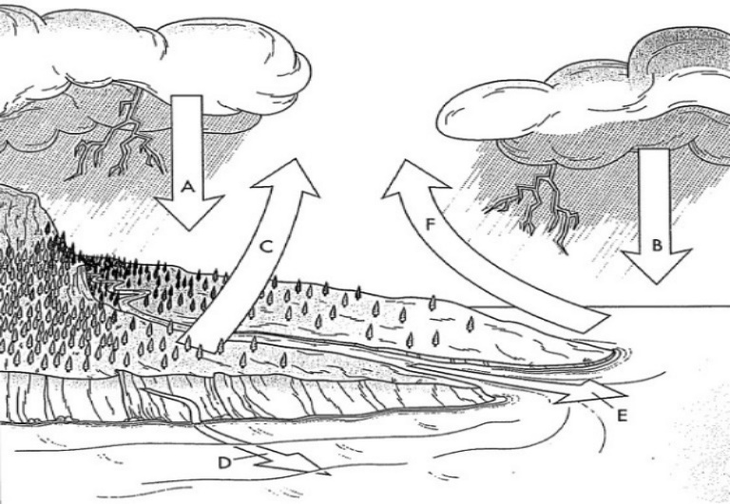 | ANSWER QUESTIONS  - What is a biogeochemical cycle?  - What 2 process move water to the atmosphere?  - Which process removes water from the atmosphere?

THE CARBON-OXYGEN CYCLE
During photosynthesis, plants use solar radiation, carbon dioxide, and water to produce sugar and oxygen. In respiration, animals react sugar and oxygen to produce water, energy, and carbon dioxide. During decomposition, organic material is broken down and carbon is returned to the atmosphere as carbon dioxide.

High temperature and pressures over time can convert carbon containing organic matter into coal, oil, and natural gas. During the burning of fossil fuels, carbon dioxide is returned to the atmosphere. Burning wood also produces carbon dioxide.

Dissolved carbon dioxide in the oceans combines with calcium to form calcium carbonate, which is incorporated into the shells of marine organisms. The hydrosphere, lithosphere, and biosphere are the earth’s major stores of carbon in the form of dissolved carbon dioxide and organic molecules.

The largest store of oxygen is within minerals of the earth’s crust and mantle. Oxygen is highly reactive and readily bonds with other elements. The reacted oxygen contains 99.5% of the total oxygen. Free oxygen in the biosphere is ~0.01% and in the atmosphere is 0.36%.

PROCEDURE  COLOR THE ARROWS  - CO₂ (A) YELLOW  - O₂ (D) BLUE  - PHOTOSYNTHESIS (B) GREEN  - RESPIRATION BY PLANTS (C) RED  - PLANT CONSUMPTION (E) DARK BLUE  - RESPIRATION BY ANIMALS (G) LIGHT BLUE  - ANIMAL WASTE AND DECAY (H) BROWN | 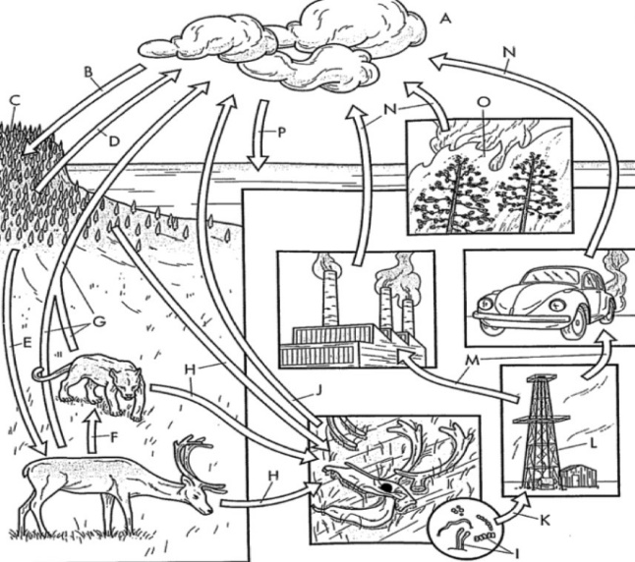 | ANSWER QUESTIONS  - Which process removes CO₂ from the atmosphere?  - Which 3 processes add carbon dioxide to the atmosphere?  - Where is the majority of oxygen stored?

THE NITROGEN CYCLE
The air is composed of ~78% nitrogen (N₂). Nitrogen is essential for life because it is a component of protein, DNA, and atp, the intercellular energy transfer molecule.

Because neither plants nor animals can obtain nitrogen directly from the atmosphere, they require the process of nitrogen fixation. Nitrogen fixation happens when lightning strikes occur or due to bacteria that live in the roots of legume plants (clover, peas, beans, lentils). These processes change N₂ into nitrate, NO₃⁻, or ammonia, NH₃. The nitrogen fixation into ammonia (NH₃) is called ammonification.

Once fixed, nitrogen is now in a usable form to be assimilated (taken up) by plant roots. The plants are then consumed by other organisms and nitrogen is passed along food chains and webs. When plants and animals decompose, nitrogen in their tissues is turned back into ammonia, once again through ammonification.

After ammonification, bacteria in the soil convert the ammonia into nitrate in the process of nitrification. Following nitrification, bacteria and volcanic eruptions change the soil nitrates into N₂ through a process called denitrification.

PROCEDURE  COLOR THE ARROWS  - ATMOSPHERE (A) BLUE  - N₂ ABSORBING INTO GROUND (B) PURPLE  - NITROGEN FIXING BACTERIA (D) RED  - AMMONIFICATION (E) YELLOW  - ASSIMILATION BY PLANTS (I) GREEN  - CONSUMPTION BY ANIMALS (J) ORANGE  - DENITRIFICATION (K) BROWN | 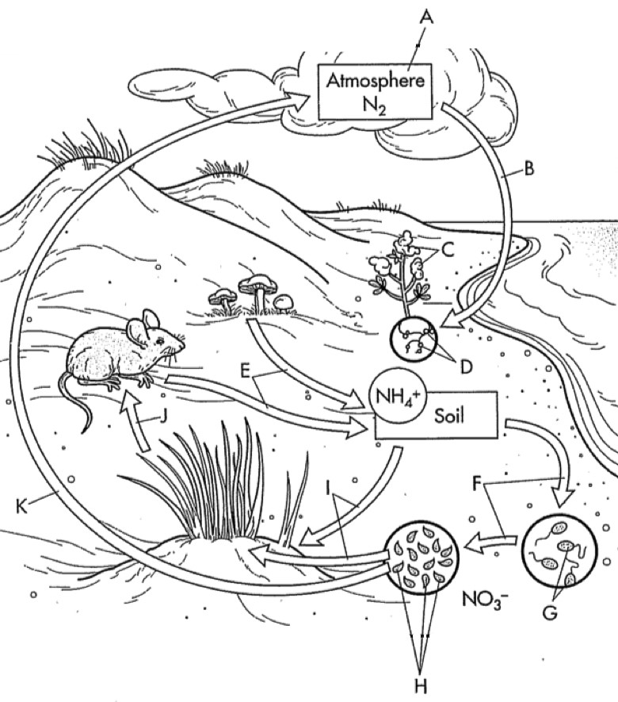 | ANSWER QUESTIONS  - Why do organisms need nitrogen?  - If nearly 80% of the atmosphere is nitrogen, how could there be a shortage of nitrogen in the soil?  - Describe nitrogen fixation.  - How do consumers get the nitrogen they need to survive?  - Why are bacteria so important to the nitrogen cycle?

