Introduction to Acids & Bases

What are Acids?
- chemical compounds made up of a hydrogen cation and a non-metallic anion or polyatomic ion (e.g. HCl, HNO₃)

- sour-tasting (if edible), corrosive, water-soluble substances

- good conductors of electricity

- wear away metals and give off hydrogen gas while the metal is changing

- when dissolved in water, they release hydrogen ions (H⁺)

Hydrochloric acid dissolved in water
HCl (_{aq)} → H⁺_{(aq)} + Cl⁻_{(aq)}

- the more hydrogen ions (H⁺) present, the stronger the acid

What are Bases?
- chemical compounds made up of a metallic cation and a hydroxide anion (e.g. NaOH, KOH)

- bitter-tasting (if edible), slippery (if safe to touch), corrosive, water-soluble substances

- good conductors of electricity

- when dissolved in water, they release hydroxide ions (OH⁻)

Sodium hydroxide dissolved in water
NaOH (_{aq)} → Na⁺_{(aq)} + OH⁻_{(aq)}

- the more hydroxide ions (OH⁻) present, the stronger the base

- while most bases contain the hydroxide ion (OH⁻), others contain the bicarbonate (CO₃⁻²) group or the sulfite group (SO₃⁻²) – really any group that will react with water to form hydroxide ions
The pH Scale
- is a scale from 0 to 14 that represents how acidic or basic a solution is
  - a very acidic solution has a low pH
  - a neutral solution has a pH of 7
  - a very basic solution has a high pH

- pH stands for the power of hydrogen – that is, the concentration of hydrogen ions in solution

- the scale is logarithmic, meaning that every change of one unit on the scale represents a ten-fold change in concentration (10¹)
  - a solution with pH 3 is 10 times more acidic than a solution with pH 4
  - a solution with pH 13 is 100 times (10 x 10) more basic than a solution with pH 11

Indicators
- chemical substances which change color when in the presence of an acid or a base

- include litmus paper, red cabbage juice, phenolphthalein, methyl orange, congo red, bromthymol blue

- Litmus paper comes in two colours: red and blue. Acid turns blue litmus paper red. Bases turn red litmus paper blue.

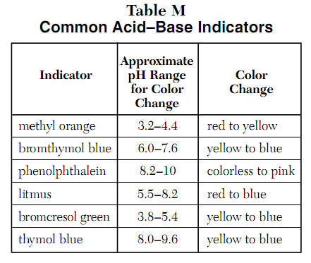
Neutralization Reactions
- When an acid and base are combined, they neutralize each other. That is, the solution contains equal number of H⁺ and OH⁻ ions.

- The products of a neutralization reaction (the combination of an acid and a base) are a salt and often water.

- Neutralization is a double-displacement reaction where an acid is neutralized by a base or vice versa.

Hydrochloric acid + Sodium Hydroxide → Sodium Chloride + Water
HCl _{(aq)} + NaOH_{(aq)} → NaCl _{(aq)} + H₂O _{(l)}

- During a neutralization reaction, the hydrogen ion from the acid reacts with hydroxide ion from the base:
H⁺ + OH⁻ → H₂O

- To determine when neutralization has taken place, an indicator is often used.

Acid-Base Reactions in the Home
- In order to make muffins, breads, cakes, and other baked goods rise, baking soda (NaHCO₃) is often used. Baking soda is a base that reacts with acids such as vinegar, lemon juice, yogurt, or sour cream to produce carbon dioxide bubbles and make the batter rise.

- Our stomachs contain hydrochloric acid and sometimes, too much acid produces pain and discomfort. An antacid tablet is a very mild base that neutralizes the acid and relieves pain.

